**LIFE-CYCLE PROCESSES: PART ONE**

**SERVICE STRATEGY: PHASES AND PROCESSES OVERVIEW**

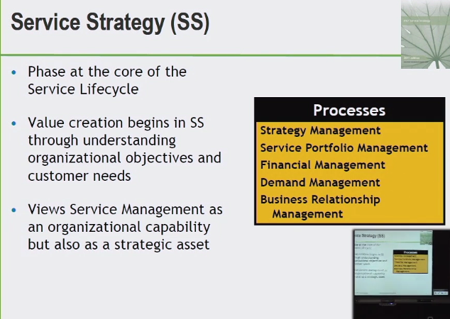

SS

1. PORTFOLIO
2. FINANCIAL
3. BUS. RELAT. MGT.

**PORTFOLIO**

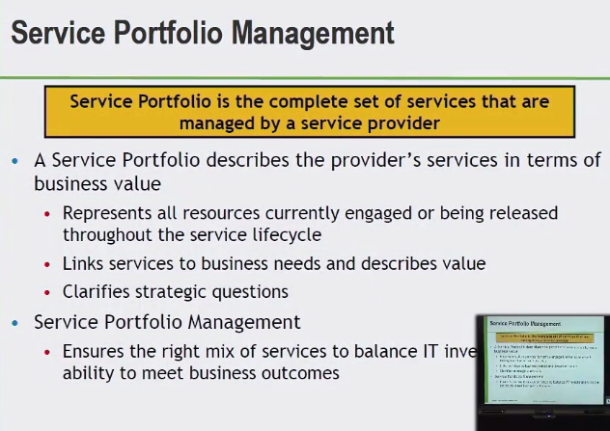

COMPLETE SET OF SERVICES (PORTFOLIO) IN TERMS OF BUS. VALUE

* RESOURCES
* COSTS
* PEOPLE TIME EFFORT MONEY
* TOWARD NEW SERVICES AND UPKEEP
* LINKS BUS. NEEDS / IT SERVICES -> BUSINESS
* INVESTMENT IN IT ALIGNED WITH CUSTOMER

WHY SHOULD CUSTOMER BUY SERVICES?

WHY BUY THEM FROM US? (OTHER PROVIDERS)

HOW DO WE CHARGE?

STRENGTHS/WEAKNESSES – PRIORTIZATION OF RESOURCES

**OJECTIVES PORT. MANAGEMENT**

1. ENABLING AN ORG. TO ASSESS WHICH SERVICES PROVIDE BASED ON POTENTIAL RETURN AND ACCEPTABLE RISK

* MAINTAIN RECORD OF SERVICES PROVIDED CORRELATED TO BUS. NEED AND OUTCOME
* EVALUATION OF SERVICES AND HOW THEY HELP ACHIEVE DEFINE STRATEGIES, HOW THEY RESPOND TO CHANGE – INTERNAL/EXTERNAL ENVIRONMENT
* CONTROL OFFERED – AT WHAT COST
* ASSESS AND REMOVE SERVICES NO LONGER IN NEED

**SERVICE PORTFOLIO AND SERVICE CATALOG**

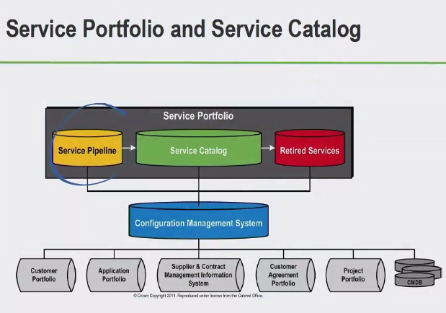

**SERVICE PIPELINE**

* LIST OF SERVICES CURRENTLY IN CONSIDERATION
* IN DEV. BUT NOT YET AVAILABLE
* PUTTING TIME RESOURCES AND MONEY AGAINST THIS
* NOT YET LIVE

**SERVICE CATALOG**

* DATABASE STRUCTURED DOCUMENT
* OUTLINES/IDENTIFIES LIVE SERVICES
* SERVICES THAT ARE CONSUMED TODAY

**RETIRED SERVICES**

* SERVICES NO LONGER BEING OFFERED

**CMS**

* MULTIPLE CMDB’S

COMPLETE SET OF SERVICES

**FINANCIAL MANAGEMENT FOR IT SERVICES**

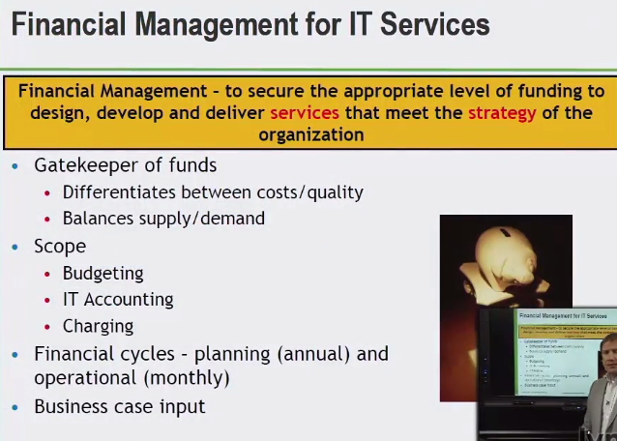

* FUNDING – DESIGN, DEVELOP AND DELIVER – SERVICES -> STRATEGY
* COST TO QUALITY – DIFFERENTIATION BETWEEN
* VALUE TO QUALITY/SUPPLY AND DEMAND
* SCOPE - ABC’S ACCOUNTING BUDGETING AND CHARGING
* ACCOUNTING – WHERE THE MONEY IS SPENT – RECORDS/BOOKS
* BUDGETING – WHERE THE MONEY WILL GO – PREDICTING EXPENDITURE ANNUALLY
* CHARGING – HOW DO WE MAKE MONEY – SERVICES CONSUMED BY CUSTOMER

OBJECTIVES

1. DEFINE MANAGE A STRUCTURE TO IDENTIFIY MANAGE COMMUNICATE COST OF SERVICE PROVISION – MEANS
2. FINANCIAL IMPACT – NEW CHANGED SERVICES
3. SECURE FUNDING – COST?
4. ENHANCE STEWARDSHIP – USE OF CUSTOMER USE AND ASSETS
5. RELATIONSHIP OF EXPENSES AND INCOME – BALANCE – MANAGE AND REPORT
6. COST RECOVERY METHODS

GATEKEEP OF FUNDS – ABC’S ACCOUNTING BUDGETING AND CHARGING

**BUSINESS RELATIONSHIP MANAGEMENT**

* STATEGIC COMMUNICATION BETWEEN CUSTOMER AND PROVIDER

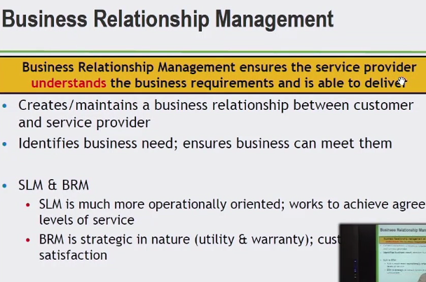

SLM – SERVICE LEVEL MAN.

* OPS. ORIENTED
* GETTING TO LEVEL OF SERVICE THAT WE DOCUMENTED

BRM – BUS. RELAT. MAN.

* STRATEGIC
* UTILITY & WARRANTY
* FIT FOR PURPOSE / FIT FOR USE
* OVERALL CUSTOMER SATISFACTION

SACM – SERVICE ASSET AND CONFIG. MAN.

CAPACITY MAN.

DEMAN MAN.

**KEY OBJECTIVES**

ENSURE UNDERSTANDING OF CUSTOMER PERSPECTIVE

ENSURE HIGHLEVEL OF CUSTOMER SATISFACTION

CREATE MAINTAIN CONSTRUCTIVE RELATIONSHIP

IDENTIFY CHANGES IN CUSTOMER ENVIRONMENT – IMPACT TYPE LEVEL AND/OR UTIL. OF SERVICES

IDENTIFY TECH. TRENDS

COMMUNICATE BUS. REQ. CHANGE/NEW SERVICES

ENSURE SERVICE PROVIDER MEETS BUS. NEEDS

MEDIATE CONFLICTS

CREATE FORMAL COMPLAINTS OR ESCALATION PROCESS FOR CUSTOMER

**SERVICE DESIGN: PHASE AND PROCESSES OVERVIEW**

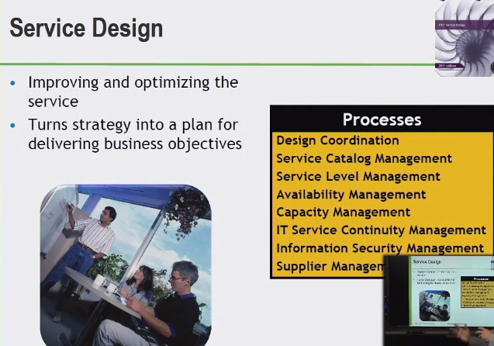

**SD**

DES. COORD

SERVICE CATALOG

SERVICE LEVEL (SLM)

AVAILABILITY

CAPACITY

IT SERVICE CONTINUITY

INFORMATION SECURITY

SUPPLIER

(PURPOSE/SCOPE)

**KEY CONCEPTS**

MULTI-LEVEL SLA’S

SERVICE IMPROVEMENT

**SERVICE DESIGN COORDINATION**

**EXAMPLE**

ROOM SERVICE:

CALL FRONT-DESK I.E. SD

3-RING BINDER I.E. SERVICE CATALOG

AVAILABLE UNTIL 11 PM (AVAILABILITY MAN.)

CALL MADE AND RESPONSE OF SERVICE STOPPED AT 9PM

PERCEIVED AGREEMENT (SERVICE LEVEL AGREEMENT)

SOMETHING CHANGED ABOUT SERVICE

NOTHING DONE TO GO BACK INTO *DESIGN*

* TO ENSURE MEASURES AND COORDINATED ACROSS PROCESSES

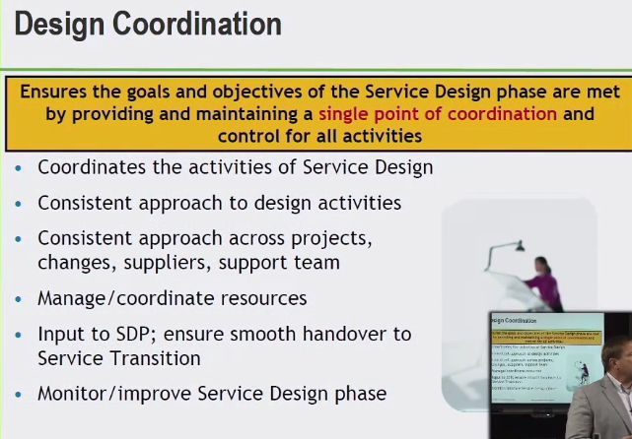

(SDP – SERVICE DESIGN PACKAGE)

* IDENTFIES EVERYONE PUT TOGETHER IN SD

**OBJECTIVES**

COORDINATION OF DESIGNED ACTIVITIES – PROJECTS CHANGES SUPPLIERS

PLAN COORDINATE RESOURCES

PRODUCE SDP HAND OVER TO ST

MAN. QUALITY CRITERIA OF REQ. AND HANDOVERS

AGREEMENT SERVICE MODEL SERVICE SOLUTION DESIGNS AND STRATEGIC ARCHITECTURAL GOVERNANCE

MONITOR AND IMPROVE LIFE CYCLE

**SCOPE**

INCLUDES ALL ACTIVITIES WITHIN THE SD STAGE/PHASE

**SERVICE CATALOG KEY CONCEPTS**

* DOCUMENT ALL LIVE AND TRANSITIONING SERVICES
* I.E. MENU (3-RING BINDER)

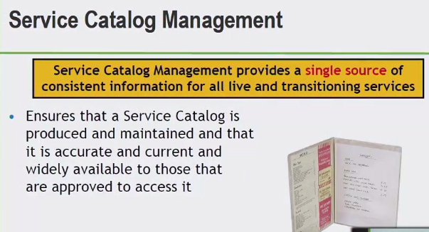

**OBJECTIVES**

1. MAN. OF INFORMATION I.E. CHANGES UP TO DATE
2. PRODUCED AND MAINTAINED – CURRENT
3. AVAILABLE FOR AUTHORIZED
4. SUPPORTS REVOLVING NEEDS IN SERVICE MAN. PROCESSES
5. ALL ABOUT SERVICES!

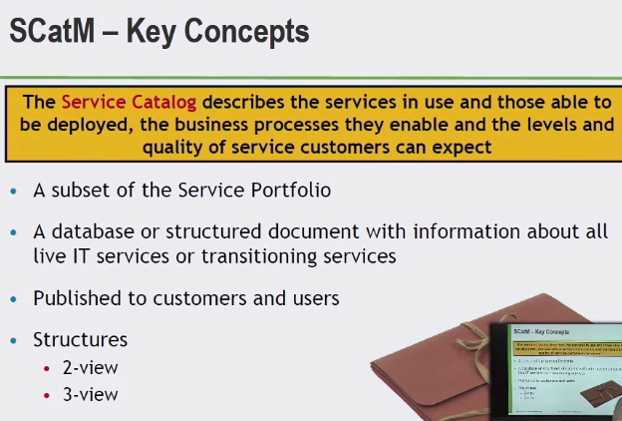

**SERVICE PORTFOLIO**

PIPELINE

CATALOG

RETIRED SERVICES

**STRUCTURES**

**2-VIEW**

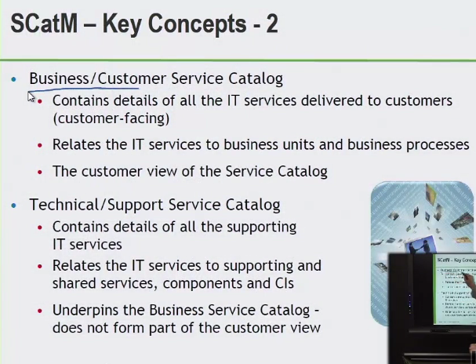

**BUSINESS/CUSTOMER CATALOG**

(ONE IN *ENGLISH* FOR USERS)

DESCRIBES AVAILABLE SERVICES

DETAILS ABOUT SERVICES

CUSTOMER-FACING

**MORE SERVICE CATALOG KEY CONCEPTS**

**TECHNICAL/SUPPORT SERVICE CATALOG**

DETAILS OF THE SUPPORTING IT SERVICES

*IT* PIECE – INTERNAL

CONFIG. ITEMS

HELPS IT SIDE

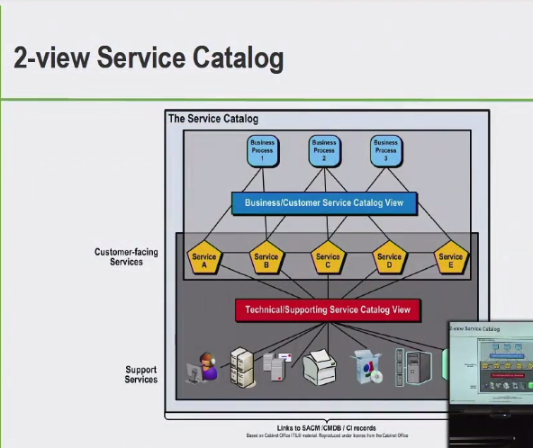

**3-VIEW**

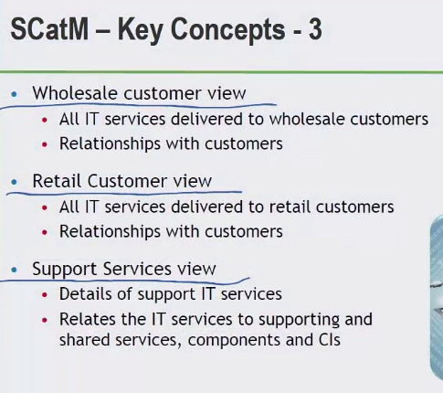

1. WHOLESALE CUSTOMER VIEW (LARGE QUANITIY SALES)
2. RETAIL CUSTOMER VIEW (LOW QUANITITY SALES)
3. SUPPORT SERVICES VIEW

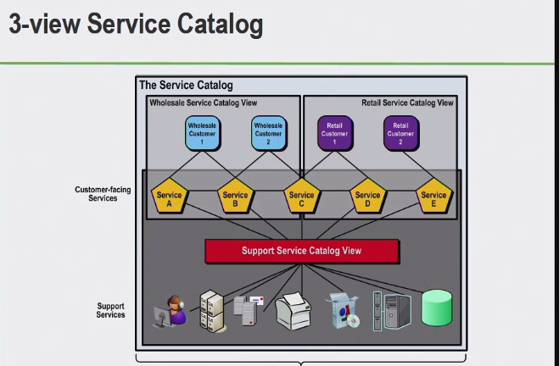

**SERVICE LEVEL MANAGEMENT: OVERVIEW AND KEY CONCEPTS**

* AGREED LEVEL OF SERVICES BETWEEN YOU AND CUSTOMERS

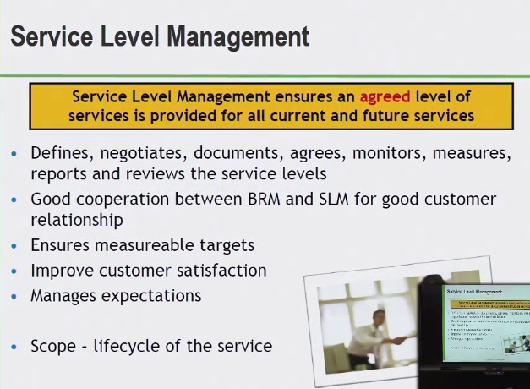

**PURPOSE**

TO ENSURE ALL CURRENT AND PLANNED IT SERVICES ARE DELIVERED TO AGREED, ACHIEVABLE TARGETS

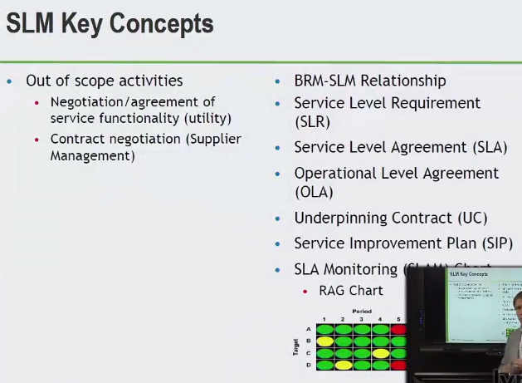

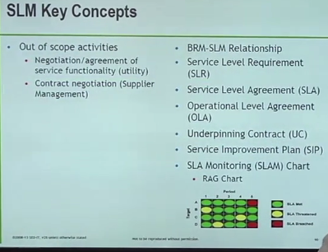

* SERVICE SIDE
* AVAILABILITY/CAPACITY/SECURITY – NOT FUNCTIONALITY!
* **(SLR) –** REQUIRED LEVEL OF SERVICES
* **(SLA) –** AGREED LEVEL OF SERVICE W/ CUSTOMER – FORMALLY NEGOTIATED DOCUMENT – RESPONSIBILITIES – HOW WILL WE DEFINE CERTAIN ASPECTS OF SERVICES – *NOT A LEGALLY BINDING DOC.
* **(OLA) OPERATIONS LEVEL AGREEMENT -** INTERNAL PERSPECTIVE BETWEEN TWO PARTS OF THE ORGANIZATION – AGREEMENT INTERNALLY
* **(UC) UNDERPINNING CONTRACT –** “RESPONSE TIME OF 1 HOUR – SPECIFIC SERVICE, SUPPLIER SAYS “WE CAN RESPOND IN 2 HOURS” AND WE HAVE A ONE HOUR AGREEMENT”
* **(SIP) SERVICE IMPROVEMENT PLAN –**

CHECK LIST OF GET WELL ITEMS – TO BE ABLE TO EXCEEDING SERVICE LEVELS – MEETING SERVICE LEVELS

* **(SLAM) SLA MONITORING**

**KEY ACTIVITIES OF SERVICE LEVEL MANAGEMENT**

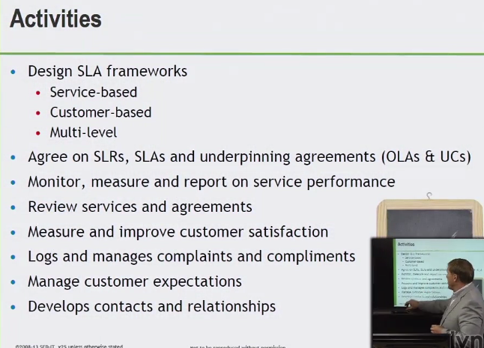

**Multi-level:**

SIMPLIFIES MAINTANENCE/REDUCE REQ/ SLA’S

**CORPORATE LEVEL**

GENERIC ISSUES – APPROPRIATE TO ALL CUSTOMERS

FROM A LARGER PERSPECTIVE/HIGHER LEVEL

**CUSTOMER LEVEL**

INDIVIDUAL CUSTOMER OR GROUP FOCUSED

**SERVICE LEVEL**

COVERS ALL ISSUES FOR EACH SERVICE USED BY A PARTICULAR CUSTOMER GROUP

*USE CATALOG TO PROACTIVELY ADDRESS BUSINESS NEEDS

**INTERFACES WITH SERVICE LEVEL MANAGEMENT**

SERVICE LEVEL MANAGEMENT CAN RELATE TO ANY PROCESS IN THE ITIL FRAMEWORK

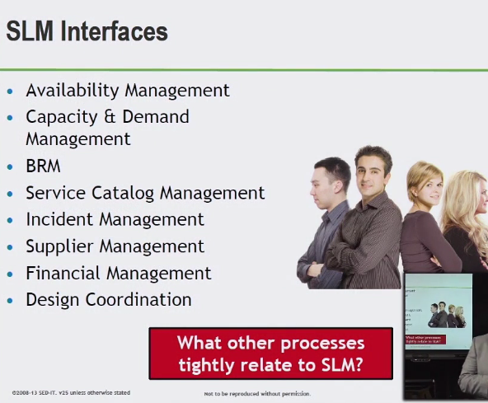

* WHAT ARE NEEDS FOR AVAILABLE MAN.
* **CAPACITY –** RIGHT AMOUNT OF RESOURCES TO SUPPORT DEMAND NEEDS FROM CUSTOMERS
* **BRM** STRATEGIC FOCUS – COMMUNICATIONS WITH THE CUSTOMERS TO SUPPORT US AT THE OPS. LEVEL
* **CATALOG –** HAS THE ACCURATE INFORMATION
* **INCIDENT MAN.** **–** NEGOTIATIONS WITH CUSTOMERS TIME FRAMES FOR DIFFERENT PRIORITIES
* **SUPPLIER –** UNDERPINNING CONTRACT
* **FINANCIAL MAN.** – PREDICTED COSTS
* **DESIGN COORD.** – COORDINATE ACROSS THE ENTIRE SERVICE DESIGN PHASE

**AVAILABILITY MANAGEMENT**

* “UP TIME”
* AVAILABILITY OF SERVICES AND COMPONENTS
* AGREED ON THESE WITH CUSTOMERS CURRENT AND FUTURE

**SCOPE**

* DESIGN
* IMPLEMENTATION
* MEASURING
* MONITORING
* MANAGEMENT
* IMPROVE OF IT SERVICE AND COMPONENT AVAILABILITY

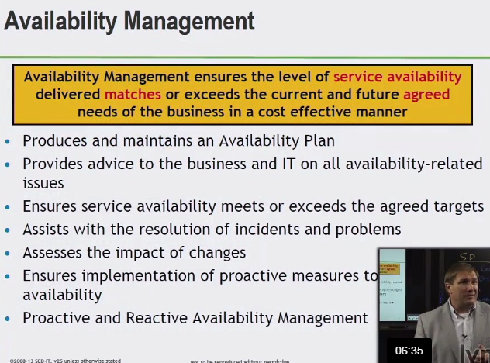

* GOOD UNDERSTANDING AVAILABLE NEEDS AND COMPONNENTS THAT SUPPORT THAT

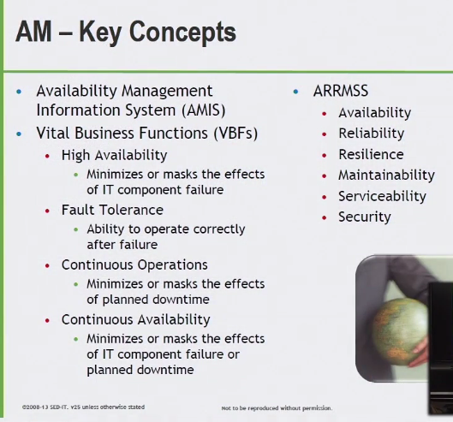

**VBF –** WHAT’S IMPORTANT TO THE BUS.

BUS. CRITICAL ELEMENTS OF A BUS. PROCESS SUPPORTED BY AN IT SERVICE

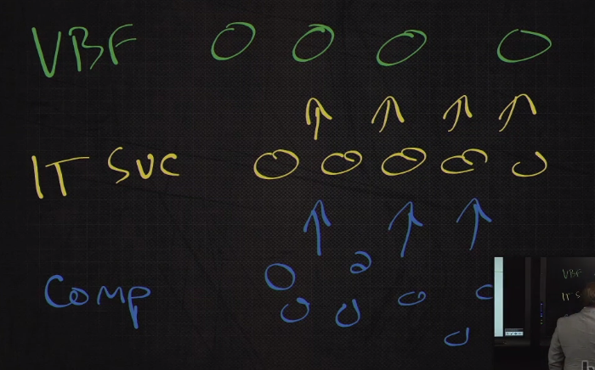

IT SERVICES -SUPPORT- VITAL BUS. FUNCTIONS

COMPONENTS –SUPPORT- IT SERVICES

**ARRMSS**

**AVAILABILITY –** TIME THAT A CUSTOMER IS ABLE TO ACCESS A PARTICULAR SERVICE EXPRESSED IN %PERCENTAGE “UPTIME”

**RELIABILITY –** THE FREEDOM FROM OPERATIONAL FAILURE UNDER SPECIFIC FUNCTIONS CONDITIONS AND TIME PERIODS

**RISILIENCE –** MEASURE OF FREEDOM OPERATIONAK OF FAILURE MINIMIZES CONSEQUENCE OF COMPONENT FAILUREVIA REDUANCY

**MAINTAINABILITY –** RESTORE IN A SATISFACTORY STATE

**SERVICEABILITY-** 3RD PARTY PROVIDERS TO MEET CONTRACTUAL CONDITIONS

**SECURITY –** CONFIDENTIALITY, INTEGRITY AND AVAILABILITY

**CAPACITY MANAGEMENT**

* BALANCING COST AGAINST THE RESOURCES NEEDED
* SUPPLY AGAINST DEMAND
* SUPPORTS THE PERFORMANCE
* RIGHT AMOUNT OF CAPACITY AND TIME

SERVICE AND COMPONENT CAPACITY

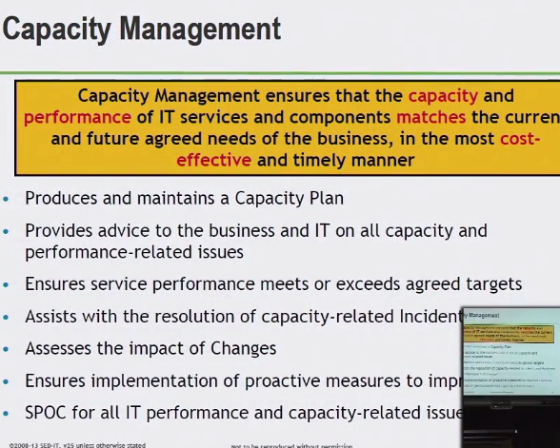

**PURPOSE**

TO ENSURE COSTS JUSTIFIABLE IT CAPACITY IN ALL AREAS OF IT ALWAYS EXISTS AND MATCHED CURRENT AND FUTURE AGREED NEEDS

CAPACITY PLAN

* ENSURE IT IS NOT THE PART OF ORG. WE ARE WAITING ON
* SCHEDULE GROWTH OF INFRASTRUCTURE

**SINGLE POINT OF CONTACT (SPOC)**

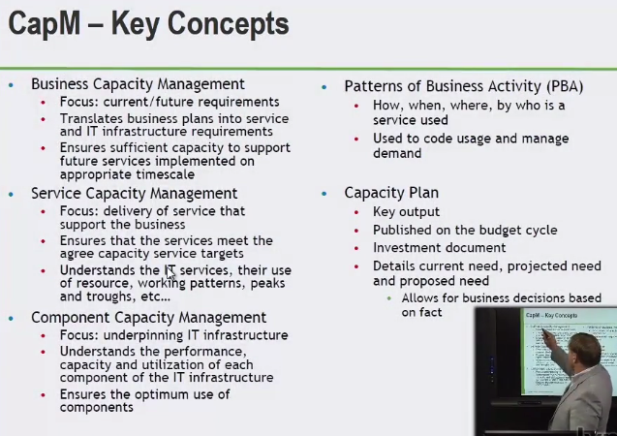

**IT SERVICE CONTINUITY MANAGEMENT**

AVAILIBILITY, UPTIME IN TIMES OF MAJOR DISRUPTION – MAJOR EFFECT ON A BUS.

ENSURING THOSE SERVICES IN THE EVENT OF THOSE EXTREME CIRCUMSTANCES

WARRANTY

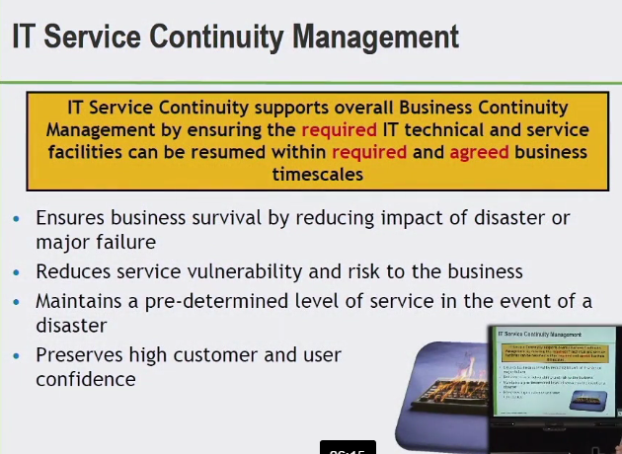

**OBJECTIVES**

PLANS RECOVERY IT PLANS SUPPORT CONTINUITY PLANS

BUSINESS ANALYSIS ACTIVITIES

BIA BUSINESS IMPACT ANALYSIS – PAIN TO BE EXPERIENCED

GUIDANCE TO BUSINESS

RISK ANALYSIS/MANAGEMENT

MEET OR EXCEED REQ. CONT. PLAN – ASSESS THE IMPACT OF CHANGES ON PLANS

PROACTIVE MEASURES TO PROVIDE AVAILABILITY

**SCOPE**

BUS. DEFINED EVENTS THAT CONSTITUTE A DISASTER TO AN ORGANIZATION

WHAT CONSTITUES AS A DISASTER?

AGREEMENT OF SCOPE OF PLAN

QUANTIFY AND QUALIFY IMPACT OF A DISASTER **(BIA) BUS. IMPACT ANALYSIS**

MUST BE SURE TO TEST IT

REQ. CONTINUITY

BUDGET, REDUDANCY, AND TESTED

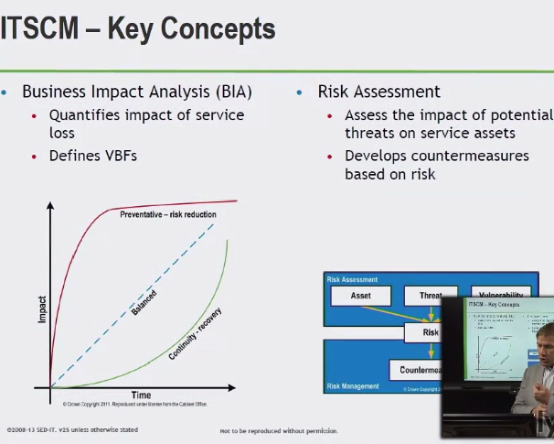

**WHAT THE IMPACT TO THE BUS. IS IF SERVICE LOSS**

FINANCIAL IMPACT? – DEGREE…

MORAL IMPACT?

HEALTH AND SAFETY?

VBF – VITAL BUSINESS FUNCTION

ASSETS AT RISK

THREATS?

COUNTERMEASURES – WHAT ARE WE GOING TO DO PROACTIVE/REACTIVE

MITIGATE – TRY TO PUT CONTROLS REDUCE LIKELYHOOD REDUCE PAIN

INFORMED BUSINESS DECISION MAKING

TO ENSURE BUS. SURVIVAL IN AN EVENT OF A MAJOR DISRUPTION IT SERVICE CONTINUITY MANAGEMENT

**SECURITY MANAGEMENT**

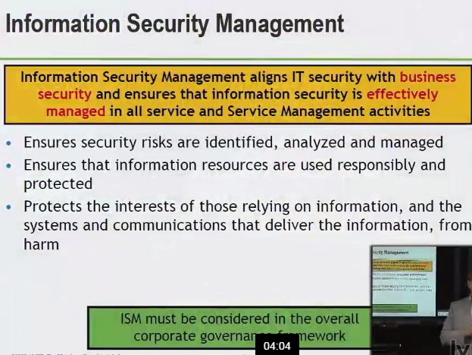

ISM – INFORMATION SYSTEM MANAGEMENT

**PURPOSE**

TO ALIGN IT SEC. WITH BUS. SEC. ENSURE THAT THE CONFIDENTIALITY, INTEGRITY, AND AVAILABILITY OF THE ORGANIZATION’S ASSETS INFORMATION DATA AND IT SERVICES ALWAYS MATCHES THE AGREED NEEDS OF THE BUS.

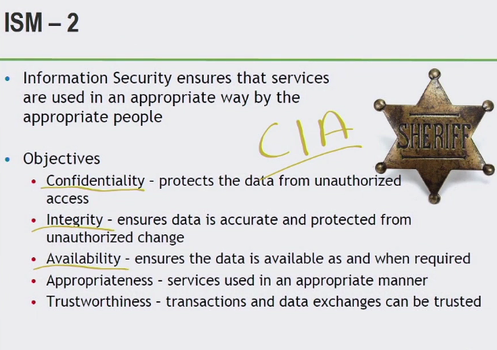

**CIA – CONFIDENTIALITY, INTEGRITY AND AVAILABILITY**

**SCOPE**

MUST DO ACROSS THE ENTIRE ORG.

BUS. POLICY ALIGN WITH SEC. REQ.

LEGISTLATIVE, REGULATORY, COMPLIANCE

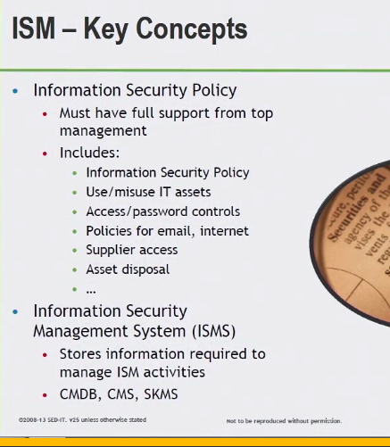

SEC. CONTROLS

RISKS

BREACHES

PROCESSES

REPORTS

MONITORING INFO

LOTS OF INFO^^^^

**(ISMS) INFORMATION SECURITY MAN. SYS.** STORES INFO ^^

CONFIG MAN. DATABASE

CONFIG MAN. SYS.

**SUPPLIER MANAGEMENT**

UNDERPINNING CONTRACTS

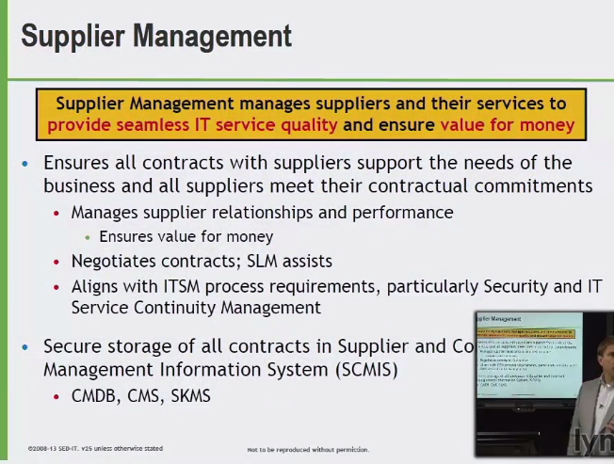

CONTRACTS

**(SCMIS) SUPPLIER CONTRACT MANAGEMENT INFORMATION SYSTEM**

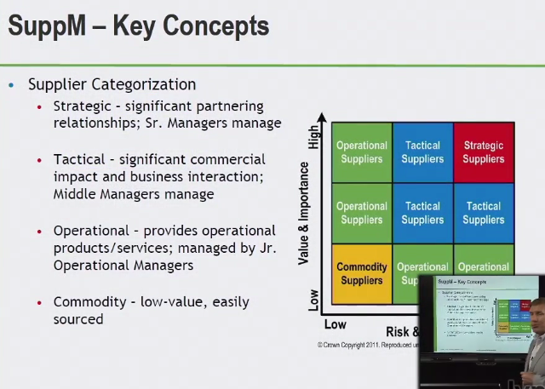

MAKE SURE YOU ARE ALIGNING WITH SERVICE LEVEL

SUPPLIER MAN. CONTRACT. INFO. SYSTEM

MANAGING SUPPLIER PERFORMANCE, KEEPING TRACK, IN SUPPORT OF PROVISIONING IT SERVICES